Script-Controlled ACL – Restrict Record Access Based on Field Value
Description :
This lab demonstrates the implementation of a script-based Access Control List (ACL) to control access to records based on specific conditions. In this scenario, access is limited to users from the EEE branch, allowing them to view only records where the Branch field is set to EEE. However, administrators are granted unrestricted access to all records.
Milestone-1 Creation of Users and Roles
User Creation:
- Log in to the ServiceNow instance with admin access.
- Create a test user:
  - Navigate to User Administration → Users
  - Click New
  - User ID: EEE User
  - First name: EEE
  - Last name: User
  - Email: eeeuser@gmail.com
  - Save the record
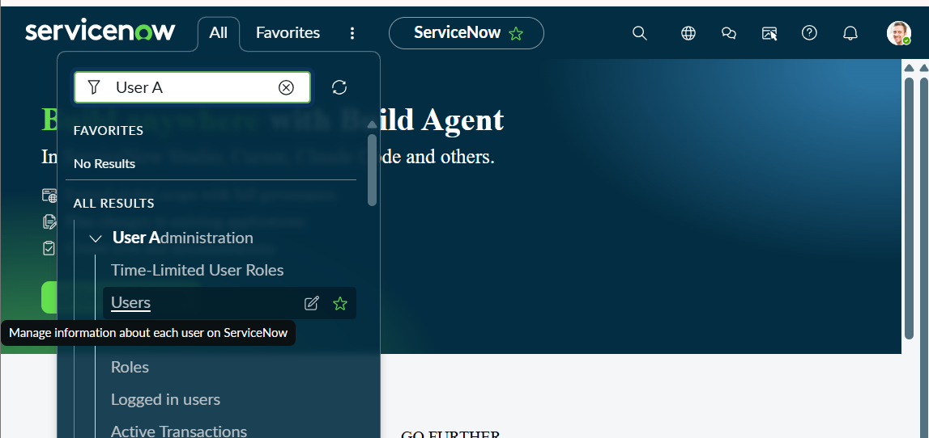
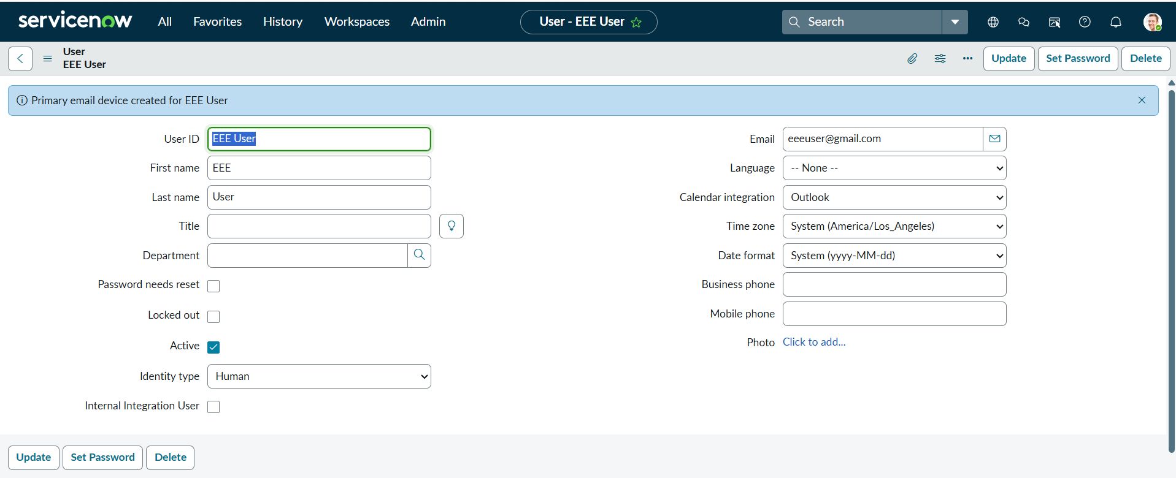
Role Creation:
- Navigate to User Administration → Roles
- Click New
- Name: Enter role name as bb1
- Description: Brief role purpose
- Click Submit
- Create other roles also like bb2,bb3,bb4.(follow the same procedure)
- Assign all the roles to the EEE User
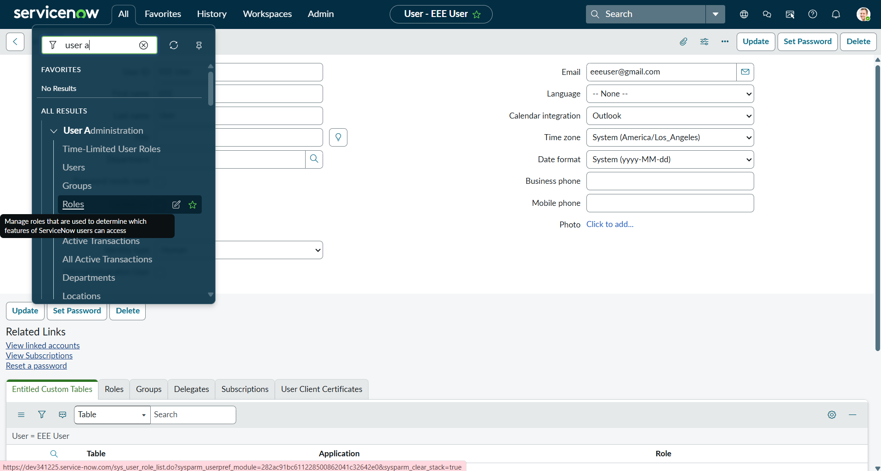
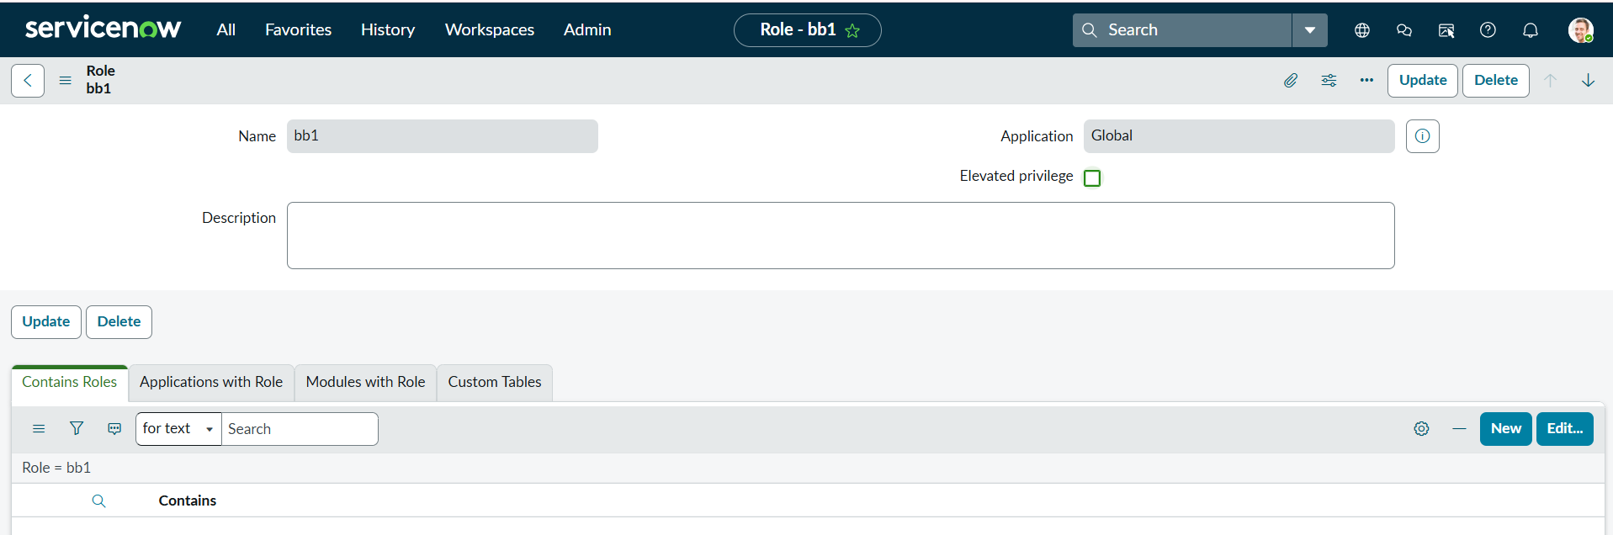

Milestone 2 : Tables Creation
- In the Application Navigator, search for System Definition → Tables.
- Click New and create a custom table with the following details:
  - Label: Institution Details
  - Name: u_institution_details
  - Extends for : false
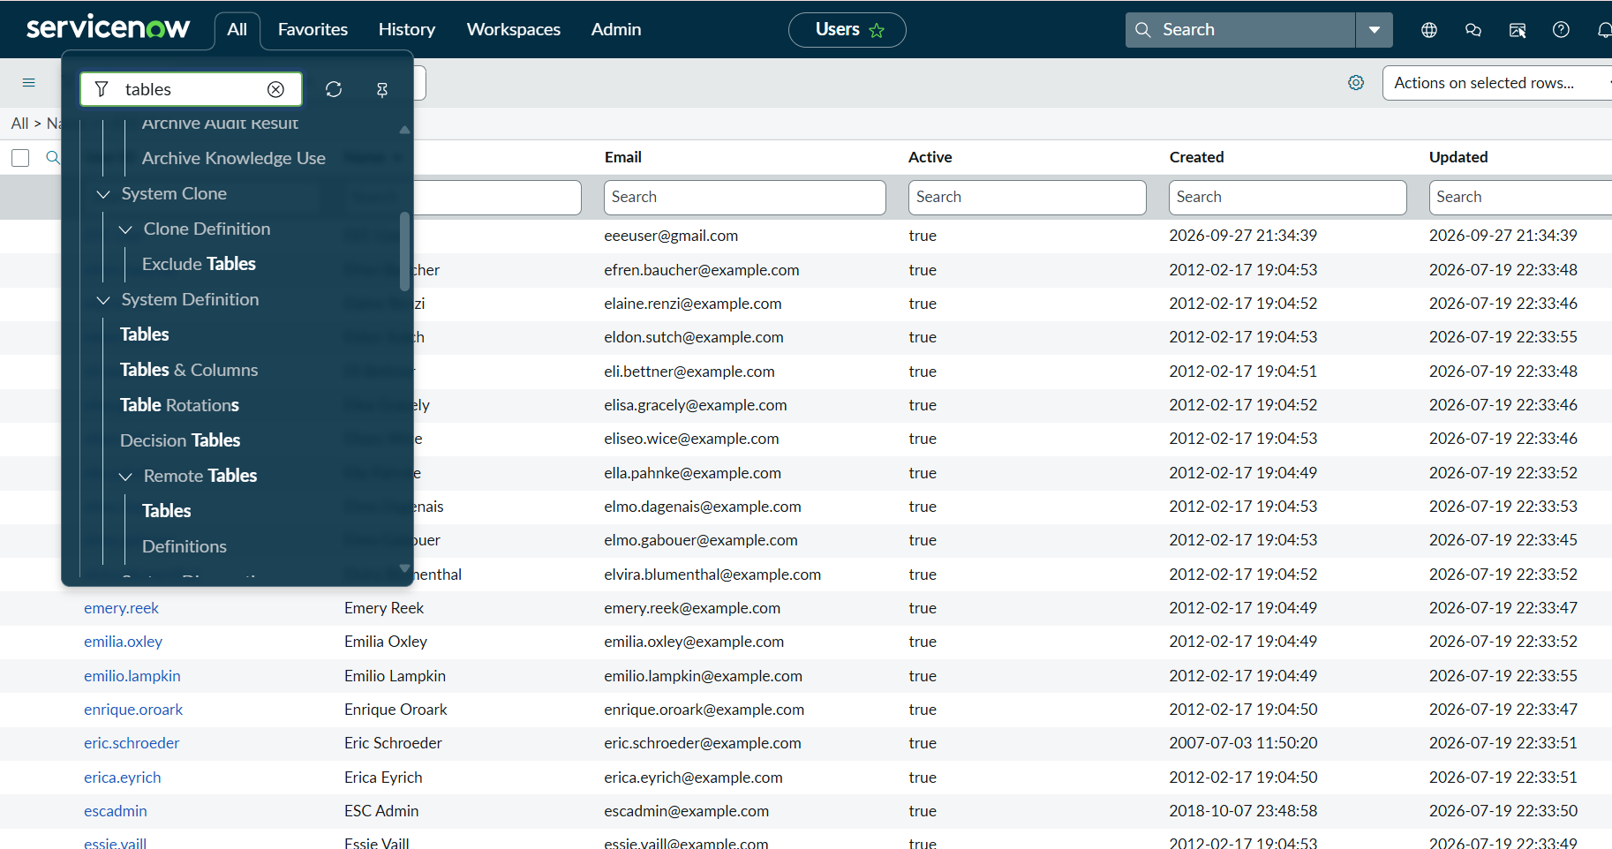
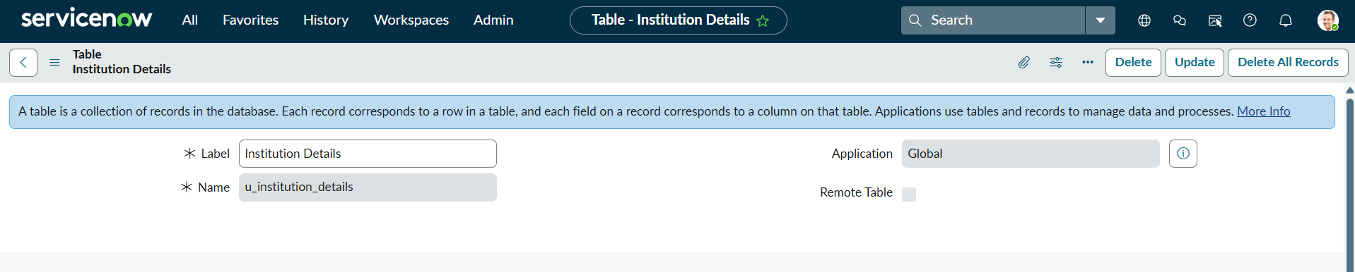
- Click Submit.
- Add the following fields to the u_institution_details table:
  - Student Roll Number– Auto Number
  - Student Name – Reference- User
  - Faculty Name – Reference- User
  - Branch – Choice (ECE, EEE, CSE)
  - Email– String
  - Phone Number– String
  - Description– Multi String
- Save the Table

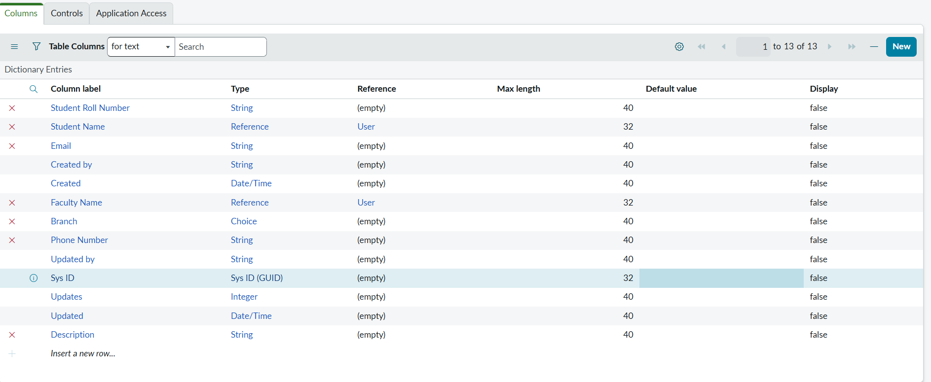

- Create multiple records in the Student Records table with different branch values (ECE, EEE, CSE).
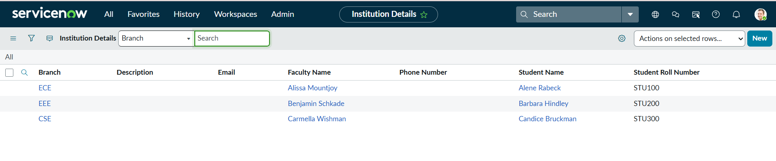
Milestone 3 : Creation of Access Control Lists(Read ACL)
- In the Application Navigator, search for System Security → Access Control (ACL).
- Elevate “Security_admin” role
- Click New to create a new ACL.
- Enter the following details:
  - Type: record
  - Operation: read
  - Name: u_institution_details
  - Active: true
  - Advanced: true
- In the Requires role related list, add:
  - bb1 (custom role)
- Add Data condition as Branch is EEE

- In the Script field, add the following script:
(function () {
// Allow admin users full access
if (gs.hasRole('admin')) {
return true;
}
// Allow only EEE branch users to see EEE records
if (gs.hasRole('bb1')){
return true;
}
// Deny access for all others
return false;
})();
- Click Submit to save the ACL.
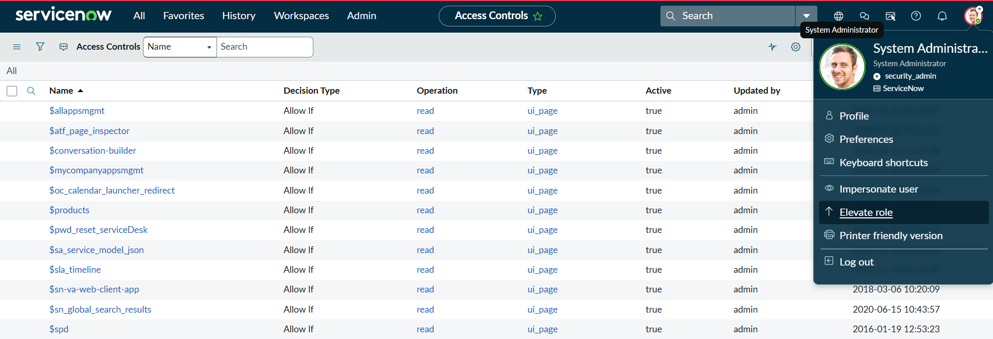
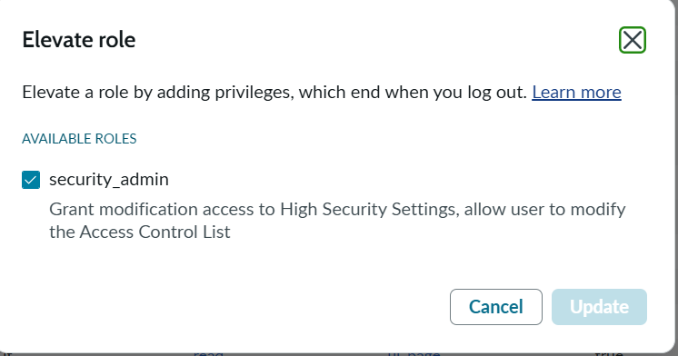
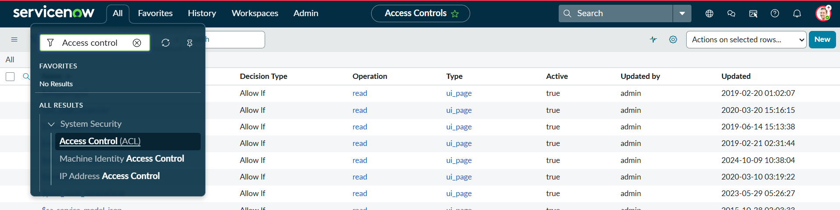
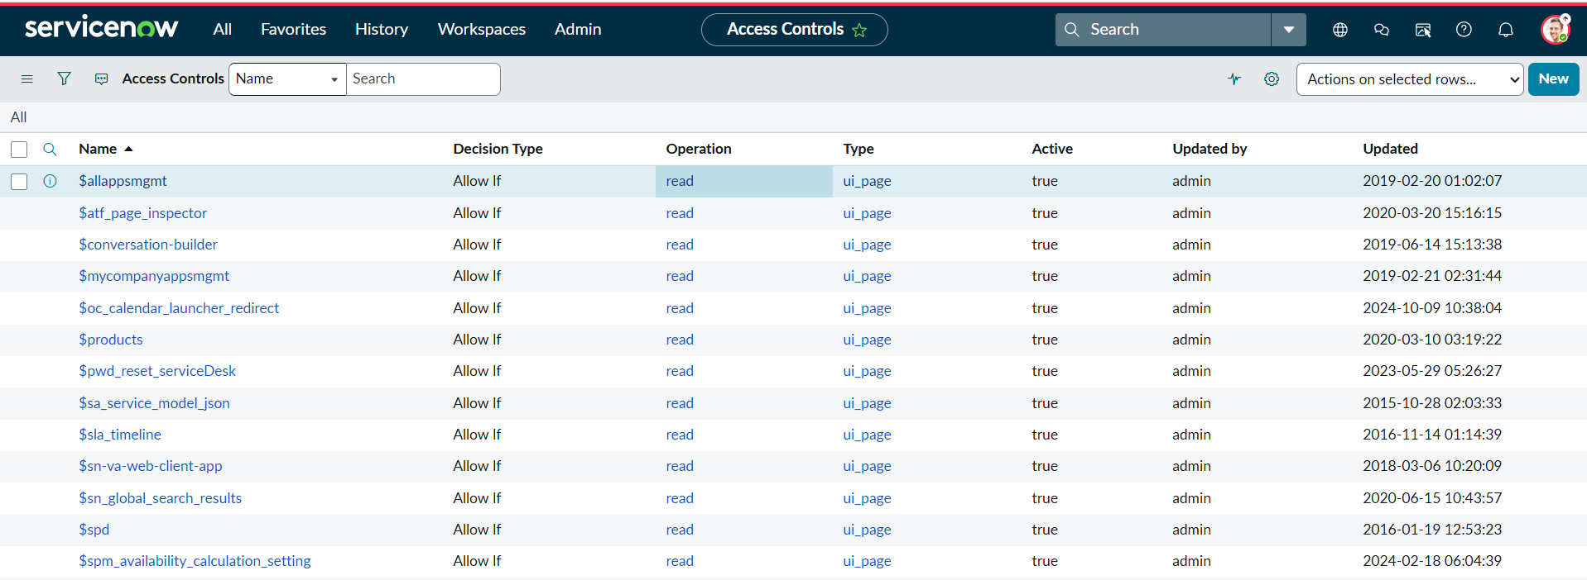
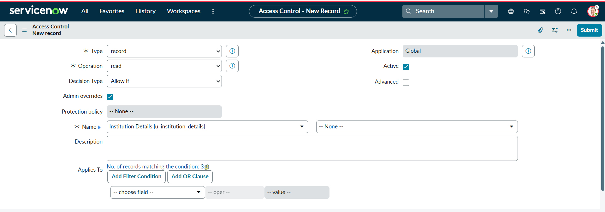
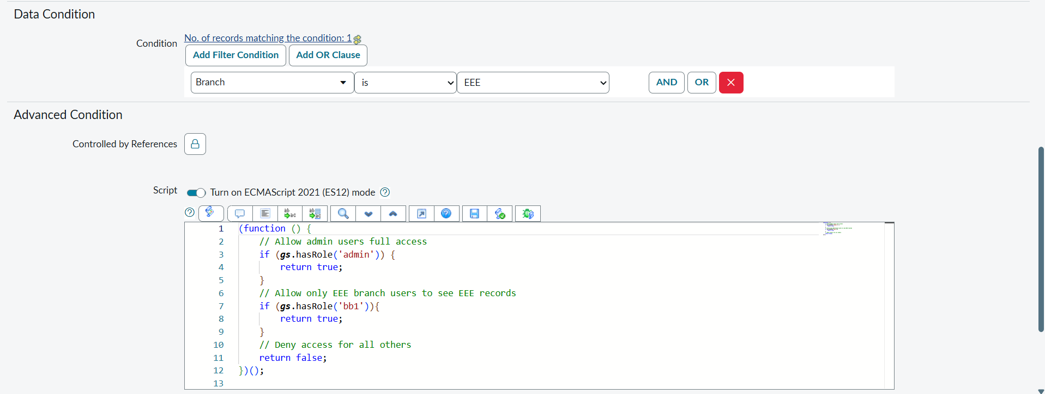
- Impersonate EEE users and open the Student Records list.
- Copy the table name u_institution_details.list/LIST and paste in the All menu.
- Impersonate Admin and open the Student Records list.
Verify :
- User with bb1 role can view only EEE branch records

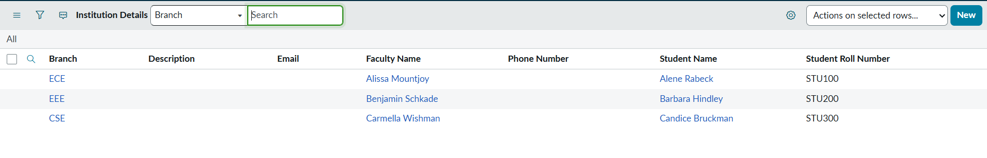
- User without the role cannot view any records

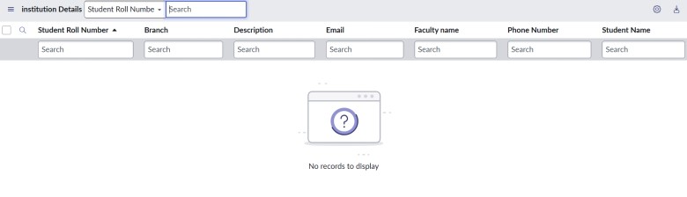

- Admin user can view all records regardless of branch

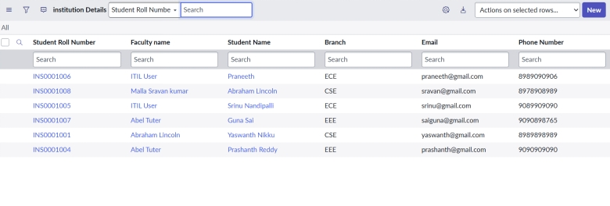

Milestone 4 : Creation of Access Control Lists(Create ACL)
- Click New to create a new ACL(Create)
- Enter the following details:
  - Type: record
  - Operation: create
  - Name: u_institution_details
  - Active: true
- In the Requires role related list, add:
  - bb2 (custom role)
- No need to add any Data condition
- Save the ACL Record
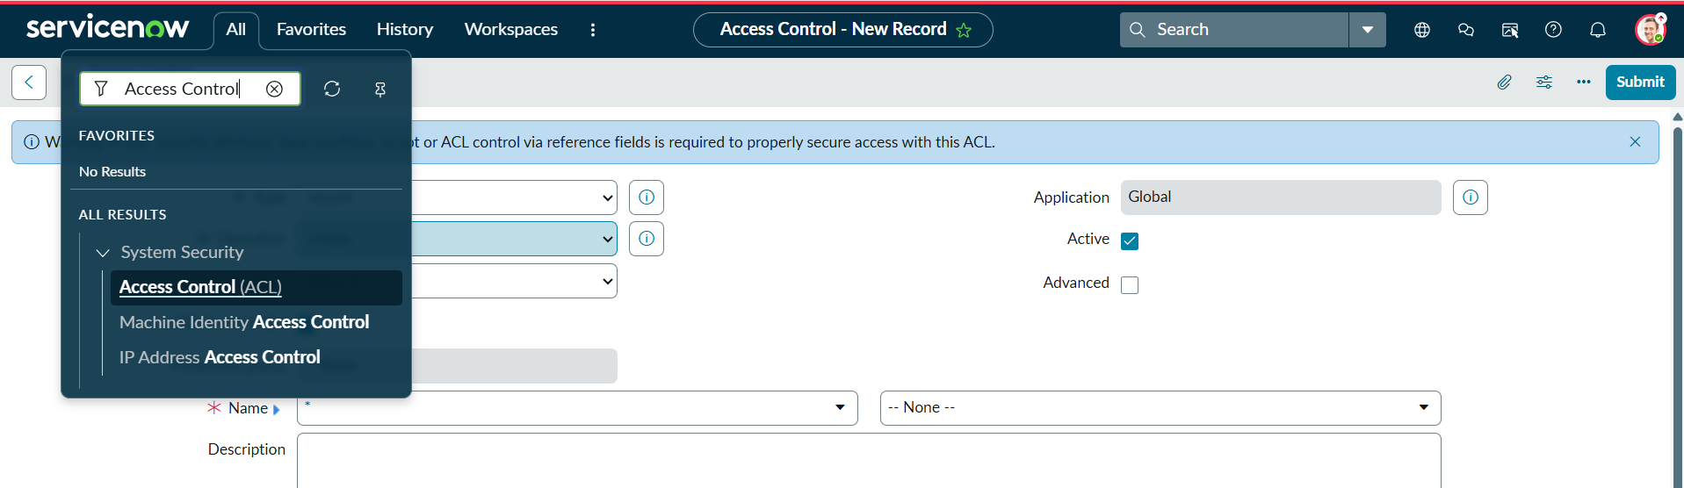
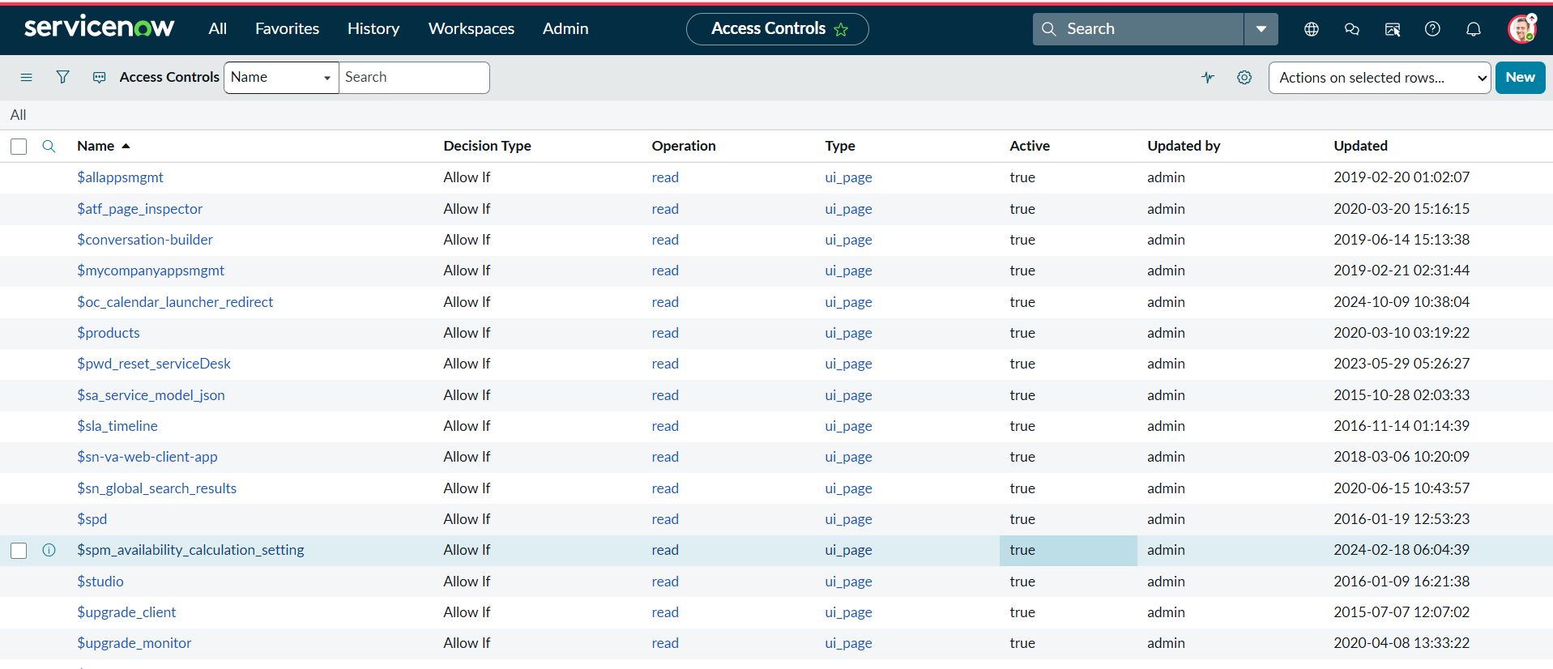
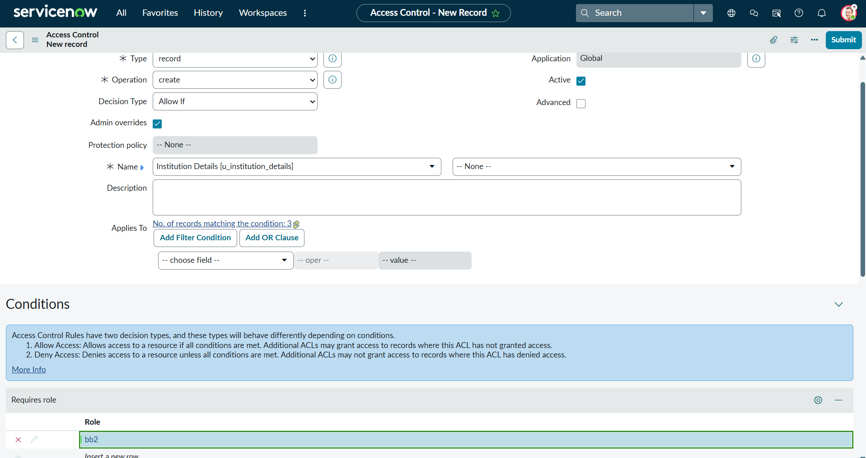
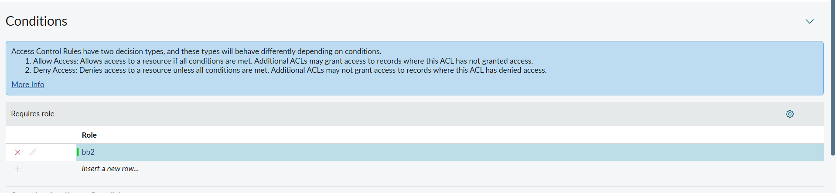
Verify :
- User with bb1 &bb2 roles can view only EEE branch records b New Button
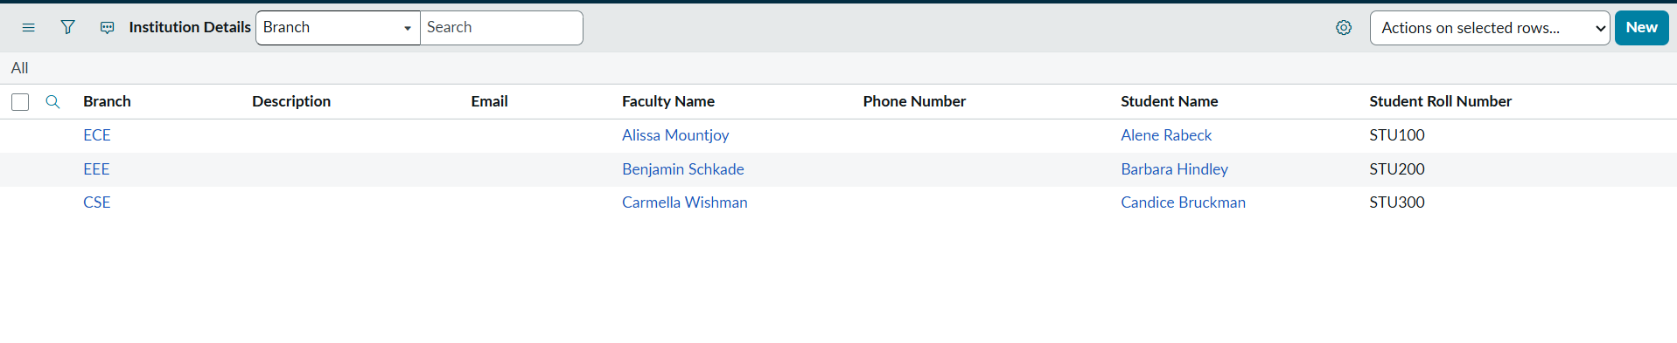
Milestone 5 : Creation of Access Control Lists(Write ACL)
- Click New to create a new ACL(Write)
- Enter the following details:
  - Type: record
  - Operation: Write
- Name: u_institution_details
  - Active: true
- In the Requires role related list, add:
  - bb3 (custom role)
- No need to add any Data condition
- Save the ACL Record
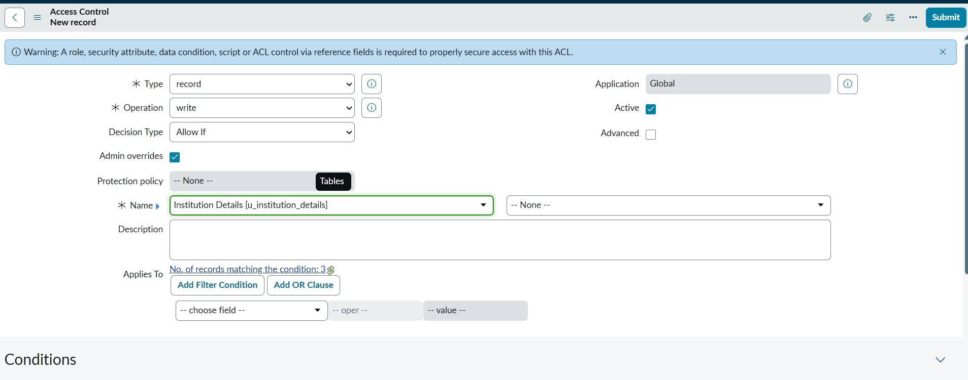
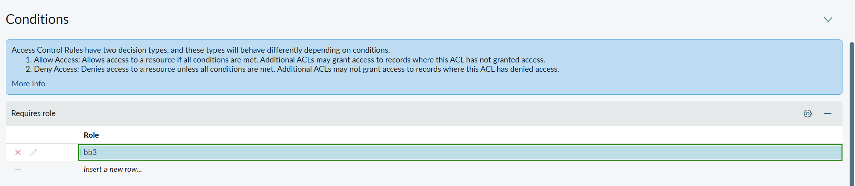
Verify :
- User with bb1 & bb2 & bb3 roles can view and edit the EEE branch records along with New Button

Milestone 6 : Creation of Access Control Lists(Delete ACL)
- Click New to create a new ACL(Delete)
- Enter the following details:
  - Type: record
  - Operation: Delete
  - Name: u_institution_details
  - Active: true
- In the Requires role related list, add:
  - bb4 (custom role)
- No need to add any Data condition
- Save the ACL Record
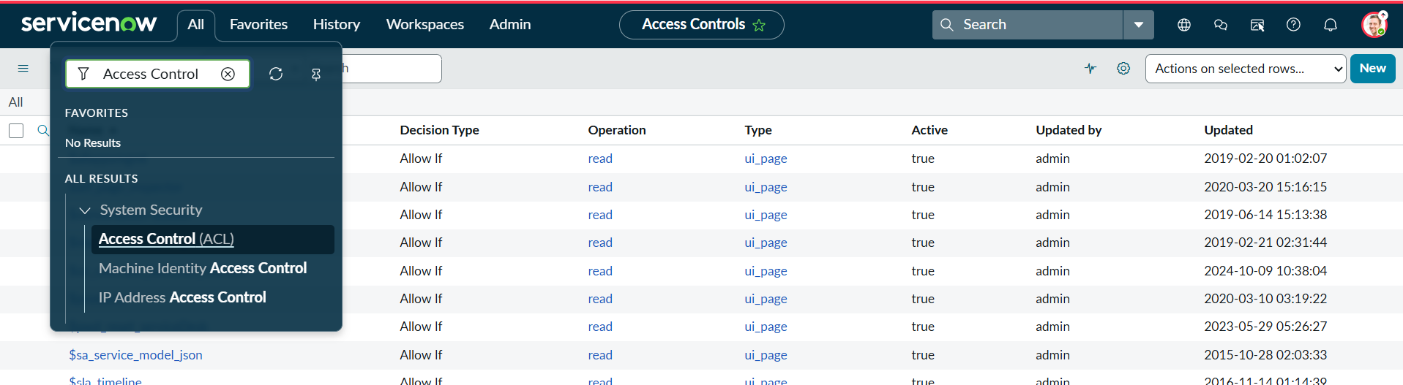
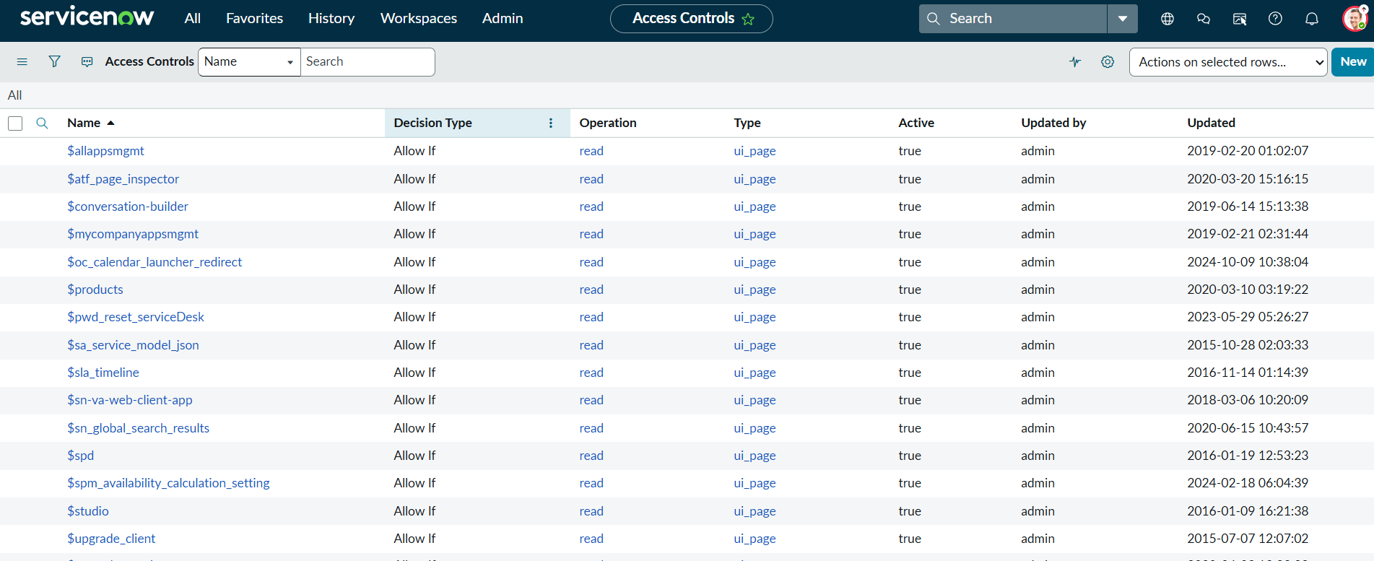

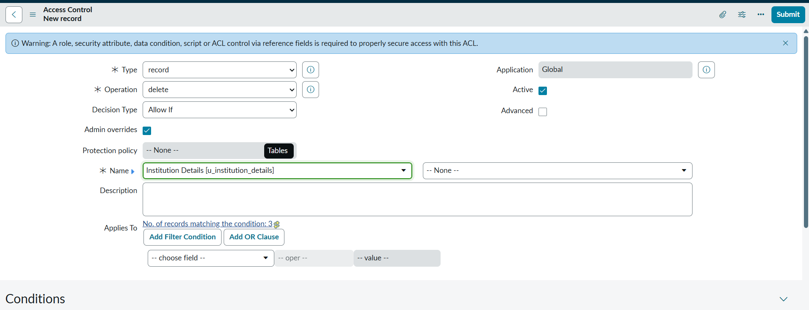
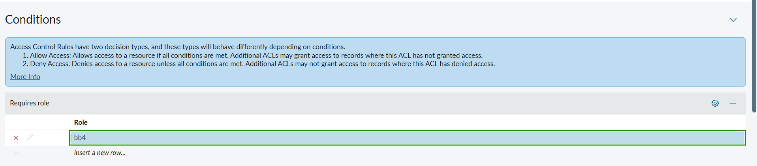

Verify :
- Users with bb1 & bb2 & bb3& bb4 roles can see, create and edit along with delete the EEE branch records.

Milestone 7 : Project Outcome

Description:
By completing this lab, learners gain a comprehensive understanding of how script-controlled READ, WRITE, CREATE, and DELETE ACLs enforce record-level security, how user roles and record field values are evaluated together to make access decisions, and how ACLs protect sensitive data from unauthorized viewing, modification, creation, and deletion across forms, lists, and Service Portal interfaces.

